Link included intext, but not working on main site or from David Copperfield walk. <https://kent-maps.online/dickens/david-copperfield-curated-walk/>

**Musical Peregrinations in 19th-century Kent**

Chris Price

The light of the moon

John Marsh (1752-1828) was a gentleman, barrister, and a talented amateur musician. According to his extensive journal, the few years (1783–7) he spent living at Nethersole, near [Canterbury](/19c/19c-Canterbury), were notable for the concerts in which he either played a leading role (as violinist, organist, composer, and/or organiser) or was an enthusiastic member of the audience. Occasionally he records a trip to London to sustain his study for the bar, though this seems by some way the less important part of his life. Apart from the prodigious musical energy of the man, the glimpses of the county's cultural life and the infrastructure – such as it was – which supported it are fascinating:

As the moon was now in its last quarter and the evening turned out to be very dark, we all found it expedient to stay till 11 o’clock, by which time the moon became of sufficient height to enlighten us on our road home. On this account, after Michaelmas it was usual for all dinner and evening engagements to be fixed for the moonlight nights, in consequence of which our engagements came so thick during the second and third quarters of the moon that we were always rather glad than otherwise when the dark nights came that we might have a few evenings to ourselves. On this account also it was usual for families settling and arranging their engagements etc., at this time of year to ask how they stood engaged during the present or the next moon.

A little later in the diary, Marsh notes that his musical activities were not always so accommodating:

These private concerts (to which Mrs M. not being a subscriber could not come) being always on dark nights I was necessitated on these nights to sleep at the inn and return home the next morning. After the public ones (it being moonlight) we always went home in the coach afterwards.

The need to be able to see where one is going may strike us as (pun intended) blindingly obvious, but darkness was not the only obstacle. Over a century later, Sabine Baring-Gould reminisced about travel along England's country roads in the early nineteenth century. Their very construction, he notes, was a matter for contention:

Road-making was formerly intrusted [*sic*] to the parochial authorities, and there was no supervision. It was carried out in slovenly and always in an unsystematic manner. In adopting a direct or circuitous line of way, innumerable predilections interfered, and parishes not infrequently quarrelled about the roads. [1]

And the quality of engineering was as might be expected:

Formerly the roads were – not exactly paved, but made by the thrusting of big stones into holes which they more or less adequately filled. Then on top of all were put smaller stones, picked up from the fields, and not broken at all. [...] Even with systematic mending, the old roads were bad, for the true principle on which roads should be made was not known.[2]

‘The wonder to me is, that chaises ever made any progress over these old roads without being splintered to atoms’ is Baring-Gould's conclusion, and Sydney Smith testifies to the problem:

In going from Taunton to Bath I suffered between ten thousand and twelve thousand severe contusions before stone-breaking McAdam was born. I paid fifteen pounds in a single year for repair of carriage-springs on the pavement of London. […] I forgot to add, that as the basket of the stage-coaches in which luggage was then carried had no springs, your clothes were rubbed all to pieces; and that even in the best society, one-third of the gentlemen were always drunk.[3]

Levels of intoxication, as will be noted, probably remained an issue, but at least roads improved: Smith's ‘stone-breaking McAdam’ was John Loudon McAdam (1756–1836): the engineer who wrought a transformation in this lamentable state of affairs. Baring-Gould explains his road-building method quite accurately:

McAdam's principle was this. Make all roads with the highest point in the middle, then the water runs off it, instead of – as in the old roads – lodging in the middle. Next, do not pave the road at all, but lay in a bottom – metal it – with broken stones, to the depth of six or eight inches, and then cover these with another layer, broken smaller, to the depth of two or three inches. Then all will be welded together into a compact and smooth mass.[4]

The improvement in travelling comfort in the first three or four decades of the nineteenth century, as McAdam's method of road building was adopted across the nation, must have been wondrous at the time. Some sense of that wonder may be found in the newspaper report below: in reporting the stunt pulled off by a local actor-manager, the *__Kentish Gazette__* clearly found the travelling more remarkable than the acting, since the report gives no clue as to what piece or pieces, exactly, Mr Sloman performed:

*Mr Sloman's professional feat*. On Thursday evening Mr Sloman, the spirited manager of this circuit [of theatres], completed his undertaking to perform in three pieces at the Canterbury, Rochester, and Maidstone theatres, within the hours of seven and 12 o'clock. The time of performing in the pieces, at the three theatres, took one hour and 48 minutes, and the time of travelling from Canterbury to Rochester, and from thence to Maidstone (36 post miles), two hours and 27 minutes, making together four hours and 15 minutes. His performances at Canterbury commenced at 7 o'clock, and closed at Maidstone at a quarter past eleven, thus completing his task in 45 minutes less than the time given. Mr Sloman was supplied with horses at the Lion Hotel, Canterbury; the Ship Inn, Faversham; the Rose Inn, Sittingbourne; and the Bull Inn, Rochester. The travelling was done at the rate of nearly 15 miles an hour, over ground by no means the most favourable for travelling. Mr Sloman was warmly greeted and cheered at the different towns he passed through, as also on his arrival at Maidstone, where he had the gratification of finishing his task to a house filled to the ceiling.[5]

For much more prosaic reasons, [Canterbury](/19c/19c-Canterbury)'s musicians would certainly have appreciated the improvement in travelling conditions.

**Music in [Canterbury](/19c/19c-Canterbury)**

A glance through the pages of a local paper at any point in the eighteenth and nineteenth centuries will furnish ample evidence of lively entertainment on offer, at least to those who could afford it and could gain access to the environments in which it took place. Stapleton's Directory of 1838 lists two venues (the Assembly Rooms and a theatre) and two musical clubs, but this hardly does justice to the vitality of the cultural production and consumption at the time: newspaper reports testify on a weekly basis to the earnest pursuit of musical entertainment. The following is typical in its somewhat formulaic celebration, although the report of a newly invented instrument is exceptional; it is to be regretted that nothing more is known of the flautocufolicon.

On Wednesday evening the [ [Canterbury Catch Club](https://www.youtube.com/watch?reload=9&v=dbKAb18w72c&t=11s) ] concert, under the direction of Mr Thomas Goodban, was exceedingly entertaining. The overtures were performed with much spirit, and the glees and songs elicited unbounded applause, particularly the inspiring song of ‘Blue Bonnets over the Border’ by Mr Beckwith, which was encored. In the course of the evening Mr Longhurst introduced a new instrument of his invention, which is a species of organ, and is an admirable accompaniment to that instrument and the pianoforte, and from its soft and melodious tones, we doubt not will soon become indispensable in every music room. It is termed the ‘Flautocufolicon’, and can be made to any size at a very moderate expense. The room was crowded, and the evening passed off with great eclat.[6]

Founded in 1779 – of which it was very proud – and very self-consciously modelled on the grandfather of all such clubs, the London Nobleman and Gentlemen’s Catch (founded 1661), the [Canterbury Catch Club](https://www.youtube.com/watch?reload=9&v=dbKAb18w72c&t=11s) met every Wednesday evening throughout the winter season, from late September to March/April. In 1833, it seems, a friendly rival was set up: the Apollonian Glee Club met on Fridays. Which means that at this point in [Canterbury](/19c/19c-Canterbury) cultural history, the city's bourgeoisie could enjoy two weekly concerts of vocal and instrumental music which catered to an eclectic taste, throughout the winter months: records survive, showing a full evening's programme consisting of solo songs, glees, and instrumental music: overtures from the very latest operas of the day or, later in the nineteenth century, dance forms such as quadrilles and polkas (see Figure 1, a printed programme from the latter years of the Club’s existence showing little deviation from the pattern). This is a level of cultural production and consumption which would be far beyond the wildest dreams of present-day arts organisers.

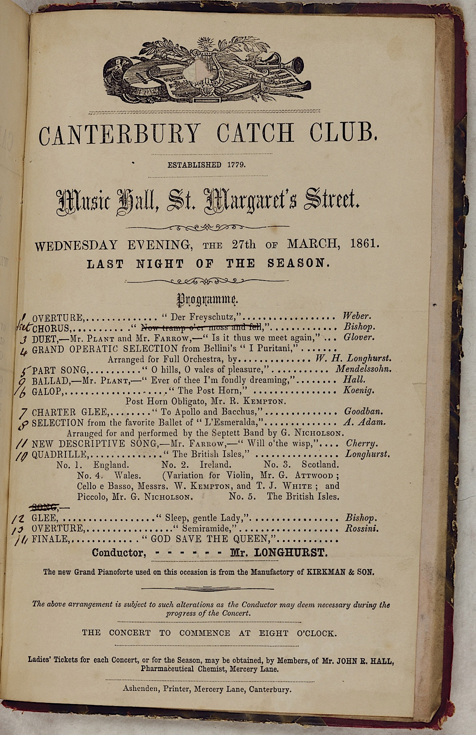

Figure 1: The last of William Henry Longhurst's concert programmes. Single sheet in bound volume, 21x13cm. Courtesy pf Kent Libraries, Registration and Archives – [Canterbury Library]( https://www.canterbury-cathedral.org/heritage/archives-library/).

It’s even more remarkable when the membership is put on a map. The Club’s records are full of the names of members, and they can be located by means of contemporary Directories. Figure 2 is a map of the city dating from 1807. About a dozen of them lived on the same street – the long central thoroughfare running diagonally north-west to south-east of the city, comprising St Peter’s Street, High Street, Parade, and St George’s Street. Several more lived and/or worked in St Margaret’s Street, which runs south-west from the centre of the city. Another dozen or so had their dwellings or premises within a few minutes’ walk of the cathedral. No-one within the city walls would have lived more than fifteen minutes’ walk from anyone else, and within those walls were to be found all the necessities of life: in the few hundred yards’ stretch labelled High Street, for example, according to Pigot, were to be found Pout the auctioneer, the bookseller George Wood, cabinet-maker William Arnold, two grocers, two hatters, an ironmonger, two linen drapers, a tailor, a chandler, a watch-maker, a pub (The Chequers), a carrier for goods to [Dover](/dickens/19c-dover), and a coach to London. The geographical proximity tightens the economic relations binding this small community together. Cheek by jowl, they lived, worked, traded, socialised and celebrated with each other in a set of overlapping networks. The men in the [Canterbury Catch Club](https://www.youtube.com/watch?reload=9&v=dbKAb18w72c&t=11s) knew each other well.

[Removed because of size]

Figure 2: 1807 Map of Canterbury (Published in London by Vernon, Hood, and Sharpe, Poultry; 1807) Engraved by G. Roper, drawn by G. Cole under the direction of E.W. Brayley to accompany *The Beauties of England and Wales*.

That such a club could be sustained is testament to the city's relative affluence: a growing bourgeoisie was eager to support such institutions, since apart from offering a good evening's entertainment they provided important networking opportunities. This is captured neatly in a very self-congratulatory lithograph dated 1826, commissioned by one of the members, Henry Ward, a local newsagent. It claims to show likenesses of many members, and those named can be corroborated by local records, but at this distance the more interesting features of the print relate to the conspicuous consumption – of alcohol, tobacco, and music – in a setting freighted with cultural signifiers. This is an explicit statement of aspirational socio-political identity.

For this essay, the most important part of the picture is the least distinct: the features of the 25 musicians in the background are lost in the haze. But it is worth noting two things by way of context: the popularity of these clubs across the nation, and the fact that this respectable, posed informality fails to tell the whole story.

Removed because of size

Figure 3: Thomas Mann Baynes: _*The [Canterbury Catch Club_* (1826) (Printed by Henry Ward, 1826). Lithograph, 51.2 x 62 cm. © Canterbury Museums and Galleries, CANCM:10840.1

The first point is simply stated: any sizeable town had a club such as this. Newspaper records testify to their existence in the nearby towns of Ashford (population in 1821, according to Pigot's Directory of 1824: 2,773), Deal (6,801), Dover (11,468), [Folkestone](/19c/19c-folkestone) (3,989), and Faversham (3,900). All are between 9 and 18 miles distant from [Canterbury](/19c/19c-Canterbury) (population: 12,745), and it’s clear that this was a distance musicians were prepared to travel to ply their wares.

The second point relates to the first: these clubs' popularity may be due in no small part to the fact that when the formal concert was over, the fun was only just beginning. You don’t see this in the print. In fact, evidence is hard to find, but the diaries of men like John Marsh and the London-based R.J.S. Stevens (1757–1837) give quite detailed accounts of the conviviality which ensued, to the accompaniment of a great deal of alcohol. [Dickens](/dickens/dickens-biography) describes a ‘Harmonic Meeting’ in one of the ‘Sketches by Boz’ (‘London by Night’) and, later in the nineteenth century, Thackeray paints a raucous picture of the whole of England ‘sounding with choruses, some ribald, some harmless, but all occasioning the consumption of a prodigious deal of fermented liquor.’ A more local account was rescued by the musicologist Percy Scholes just before the crucial witness died: this account by a Mr Mount can be only approximately dated, but it seems roughly contemporary with the print:

When the program was concluded the early birds retired, and for some forty years the after evening was celebrated by amateur free and easy singing, the mirth growing fast and furious till the small hours. No Bruce [police] being then in existence, our grandfathers made a night, and often, too, a morning of it.[7]

The Music

The ‘amateur free and easy singing’ of the ‘after evening’ Mr Mount describes probably included more comic songs from the leading lights of the club’s entertainment roster, but it is utterly beyond question that most of the music being enjoyed in these fiercely convivial evenings was the quintessentially participatory genre, the catch.

The catch has a long history: ‘Sumer is Icumen In’ dates from the thirteenth century; Shakespeare makes reference to it, and Pepys records singing them socially with friends. Nowadays, we would call such a piece of music a round: in essence, it consists of a single melody, broken up into phrases of equal length (usually three or four), which may be sung not only consecutively, but concurrently. The composer’s skill is then evident, as the underlying harmony becomes audible. In performance, the singers begin the melody in turn, each beginning when the preceding singer reaches the end of the first phrase, and all will simply repeat the melody until, by common consent or musical mishap, all stop. But the real delight of the catch is as much textual as musical: in the more salacious examples, a double entendre may only emerge when the voices combine. This is the kind of repertoire which has tainted the reputation of the catch. Most of the blame for the bad press may be laid firmly at the feet of Henry Purcell, but other composers contributed even more dubious specimens of the genre, often with far less musical ingenuity, and so the catch embarked upon the 1700s in very bad odour. For many, nothing changed in that century: in 1795 the composer and cleric William Jackson described them as pieces which ‘when quartered, have three parts obscenity and one part music’.[8] One short example will suffice: Luffman Atterbury’s ‘As t’Other Day Susan and Tom Trudg’d Along’, begins as a light-hearted tale of Susan and Tom attempting to sing a song. Tom is less competent than Susan, and keeps losing his place. His entreaties to Sue to help him regain it (‘let me in’) are met with smiling rebuffs, since she doubts his ability, at which point Sam comes along and offers to fill Tom’s role. In case the double-entendre had not become sufficiently clear, Atterbury’s setting reinforces it in bars 7 and 8 by means of the carefully placed pauses in the different voice parts.

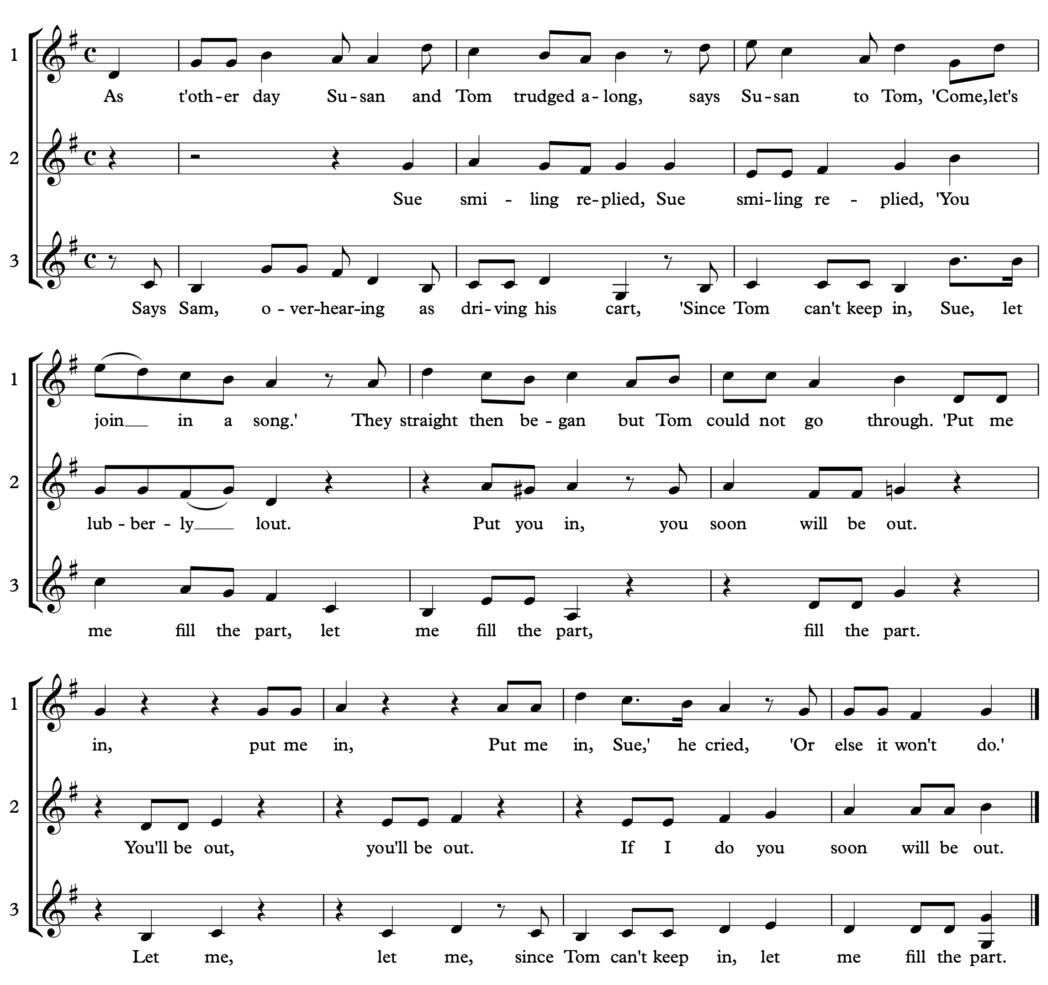

Figure 4: Luffman Atterbury (1735–1796): *As t'other Day Susan*

The crucial point about the catch is that in performance, all were expected to participate, subsuming the roles of both performer and audience; our very modern tripartite relationship between composer and the other two partners in the transaction does not apply to this repertoire. This is music which, in a very literal sense, was *never intended to be listened to*. It must have been intensely enervating, as the different lines were bellowed across the crowded room in a kind of competitive polyphony. And that is what Mr Mount meant when he described the fun as ‘fast and furious’.

The natural home of the catch was the tavern – Toby Belch invites everyone to sing one in *Twelfth Night*. In that environment, it sat cheek by jowl with the glee.

It is difficult to overstate the popularity of the English glee in the late eighteenth and early nineteenth century. Evidence abounds: in the concert programmes reported not only from [Canterbury](/19c/19c-Canterbury) but from everywhere else in the British Isles; in the sheer volume of publication (one estimate suggests that the 25,000 surviving pieces were matched by an equal number of compositions which never made it into print); contemporary diarists who recorded their music-making; Banquet Cards from civic ceremonies recording not only the gastronomic but the musical fare on offer for the evening (see Figure 5); its established place in the choruses within the mongrel form of opera known as English Opera popularised in the late eighteenth and early nineteenth centuries by the likes of James Hook, Henry Rowley Bishop, and William Shield; and in the strenuous efforts to nurture its growth by means of generous prizes awarded by the variously named Catch Clubs, Glee Clubs, Harmonic Societies and other musical assemblies up and down the country.

In the end, none of this could ensure the survival of the glee beyond the end of the nineteenth century, though echoes can be heard in some Gilbert and Sullivan choruses and there is one report of a Glee Club behind the lines in World War 1. By then, though, the repertoire is indistinguishable from the choruses and part songs which had become popularised in the volumes of music aimed at the enthusiastic amateur, middle-class, domestic music-making which had grown up alongside the advent of readily available pianos for the home.

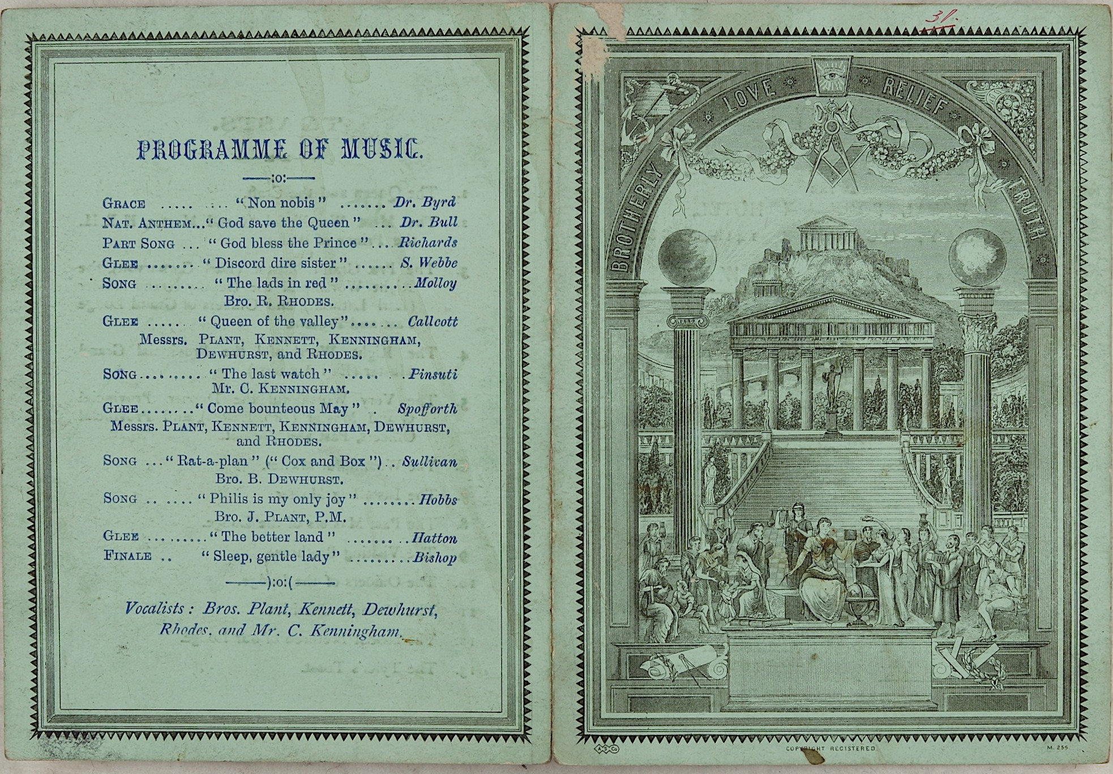

Figure 5: Banquet card, 14 October 1889, card, 13 x 19.2 cm . Call ref.: ‘Menus from Civic Banquets, 19th and 20th century’. Courtesy of Kent Libraries, Registration and Archives – Canterbury Library.

In its heyday, the glee was a rather more demanding genre requiring a level of vocal dexterity and musical training not normally associated with amateur music-making. The men who sang the glees at a Catch Club evening were more likely to be professional singers. Fortunately for Canterbury – and for every other cathedral city throughout the land, and for the nearby towns who may also have and a Catch or Glee Club to which these musicians could travel along the rapidly-improving roads of the nineteenth century – there was a ready supply of such talent in the local cathedral choir.

Cathedral Singers

Since the dissolution of the monasteries in the 1540s, the new cathedrals constituted by statute had allowed unordained men to swell the ranks of the choir required to sing the two prescribed daily offices – Matins in the Morning and Evensong in the afternoon. Ordained men – so-called Minor Canons – sang alongside them, but it was a rare cathedral which could find enough to make up the alto, tenor and bass lines, so ‘Lay Clerks’ (or, in some places, ‘Lay Vicars’) were employed to do the job. [Canterbury](/19c/19c-Canterbury) had twelve of them (four of each voice), alongside the six Minor Canons and ten boy Choristers.

The work of a Lay Clerk never has been a full-time job, and has never paid a wage that would enable a man to house, clothe, and feed himself, let alone a family. A scrutiny of civic documents alongside cathedral records enable a guess as to what else some of them did, though anything gleaned from outside the Precincts is rather more speculative. As an example, the men who sang in the cathedral choir in the year of the [Canterbury Catch Club](https://www.youtube.com/watch?reload=9&v=dbKAb18w72c&t=11s) print, 1826, are listed below (Figure 6), but the only two in this cohort whose occupations might be confidently identified are the first, Shrubsole, a saddler, and the fourth, Pillow, who was a hoyman – and possibly a smuggler, at least during the Napoleonic Wars.

Almost all of them however, appear in the [Catch Club](https://www.youtube.com/watch?reload=9&v=dbKAb18w72c&t=11s) records (quite exhaustive Minutes were kept, and survive, from 1802) as singers, orchestral players, and as functionaries of other sorts for which some small remuneration is paid: Check [*sic*] Taker, or Librarian. Many also crop up in newspaper reports of concerts in and around the city. It becomes clear that these musicians were keen to hawk their time and talents around wherever such piecemeal employment could be found.

|  |  |  |  |
| --- | --- | --- | --- |
| **Name** | **Dates of service** | **Years service** | **Reason for leaving** |
| James Shrubsole | 1773–1825 | 52 | Death |
| William Loop | 1778–1830 | 52 | Death |
| Thomas Halsey | 1784–1830 | 46 | Retirement |
| Edward Pillow | 1789–1836 | 47 | Retirement |
| *Highmore Skeats | 1803–1831 | 28 | Death |
| Thomas William Halsey | 1815–1850 | 36 | Retirement |
| Edward Nicholson | 1818–1854 | 37 | Retirement |
| Samuel Newington | 1818–1834 | 16 | Dismissal |
| **Thomas Jones | 1821–1872 | 53 | Death |
| Stephen Elvey | 1823–1830 | 7 | Move to Oxford |
| Castle Kempton | 1823–1860 | 38 | Retirement |
| Charles Henry Dobson | 1825–1839 | 14 | Unknown |
| James Shoubridge | 1826–1840 | 14 | Move to London |
| * (Organist 1803–31)  ** (Assistant Organist 1824; Organist 1831–72) | | | |

Figure 6: The 13 men who served in the Cathedral Choir in the year coinciding with the production of the lithograph in Fig. 3

The thirteen Lay Clerks (including two Organists) who served in the Cathedral Choir in 1825–6 reach back to 1773 and forward to 1872; their period of service spans just one year short of a century. This encompasses the entire life-span of the[Canterbury Catch Club](https://www.youtube.com/watch?reload=9&v=dbKAb18w72c&t=11s): from Shrubsole’s appointment in 1773, six years before the official formation of the Club, to Thomas Jones’ death in 1872, seven years after the [Catch Club](https://www.youtube.com/watch?reload=9&v=dbKAb18w72c&t=11s) disbanded itself. It is, however, a coincidence of charming serendipity that the last musician on the list, James Shoubridge, was appointed to replace the first of these thirteen singers: ‘Mr James Shoubridge was elected & admitted a Lay Clerk in the room [i.e., the place] of Shrubsole, deceased.’[9]

To those unfamiliar with the world of cathedral musicians in the centuries between Henry VIII and Victoria, there are some aspects of this bald account which require immediate explanation. The mortality rate amongst Lay Clerks seems alarmingly high; the deaths in service of one-third of those named gives the impression that cathedral singing is a hazardous occupation. This is explained by the fact that Lay Clerks, like their ordained colleagues, were appointed for life—which also accounts for the strikingly lengthy periods of service of some of the men.

Almost all of these men were active members of the Catch Club, singing and/or playing in the orchestra on a regular basis throughout their adult lives, so were prominent in the city’s musical life. Several, however, travelled further afield. Newspapers report the activities of nearby clubs; taken together, this paints a picture of the roads of Kent populated not only by the commerce of coaches, omnibuses, vans, post-chaises and carriages mentioned in the Directories, but by those peddling their cultural contributions around their corner of the country. What follows are a few examples.

Charles Henry Dobson

Charles Henry Dobson is not mentioned in the [Catch Club](https://www.youtube.com/watch?reload=9&v=dbKAb18w72c&t=11s) records, which is also odd because his name crops up repeatedly in newspaper reports covering everything else musical in this period. He and James Shoubridge are frequently found performing together, as here at the Catch Club in the nearby coastal town of Deal in 1833: ‘Messrs Shoubridge and Dobson were as usual quite ‘at home’ in the parts assigned them, and gave great satisfaction’.[10] In 1834, the same singers joined the Ashford Catch and Glee Club in a meeting attended by ‘250 gentlemen of the town and neighbourhood, being the largest, and at the same time, the most respectable convivial meeting ever held within [the Assembly Rooms’] walls.’ The usual rules applied: ‘in the after evening these gentlemen entertained the company with a great many first-rate songs, glees, and catches, which obtained the most enthusiastic applause, as did several songs given by the amateurs of the neighbourhood.’ They were not alone: ‘The orchestra was composed of the Ashford amateurs, assisted by several professional gentlemen from Canterbury.’[11] They returned to Ashford—with more of the Canterbury men—in April to round off their season.[12]

The [Catch Club](https://www.youtube.com/watch?reload=9&v=dbKAb18w72c&t=11s) was not the only purveyor of convivial music at this time, and the musicians showed no favouritism when their talents were sought: familiar names crop up, for example, in a report of an Apollonian Catch Club meeting in April 1834. It is the only reference to identify Dobson as a bass, and it is also noteworthy for the piano and harp duet performed by the young Masters Longhurst and Mount: ‘a surprisingly clever performance for so young hands.’ This prompted the unexpected celebrity visitor, ‘Mr Hart, the celebrated quadrille composer,’ [Joseph Binns Hart, 1794-1844] to congratulate the company. According to the report he ‘concluded thus: ‘Proud am I to say, that while juvenile talent is so fostered as it appears to be here, Englishmen will never have cause to fear the invasion of any foreigners.’ He then delighted the company by performing ‘God Save the King,’ with variations, on the pianoforte, and amused a numerous company to a very late hour.’[13] The conviction that invasion by a foreign foe may be deterred with a piano and harp duet probably owes more to the convivial temper of the evening than any historical evidence, but the alacrity with which a provincial musical club may prompt an evocation of national moral fibre is interesting, as is the fact that the traffic of musical personalities was not all one-way: Canterbury attracted musicians from outside the city besides sharing its own with the locality.

The Apollonian Catch Club showed a notable readiness to vary its musical offering in 1834 by holding meetings ‘at the Half-way house between this city [Canterbury] and [Dover](/dickens/19c-dover).’ In May, at the last of them, ‘upwards of seventy of the surrounding neighbourhood […] met together upon the occasion.’ Once again, Shoubridge and Dobson are in evidence.[14] They and their fellow Lay Clerks continually appear throughout this period at the civic occasions marked by sumptuous dinners enlivened by the music of these men: inaugurations of councillors and mayors; a dinner ‘In Commemoration of His Majesty’s Declaration to preserve inviolate the Constitution in Church and State’ in September 1834;[15] an ‘Inauguration Dinner’ celebrating the election of a Jurist of [Dover](/dickens/19c-dover), attended by His Grace the Duke of Wellington in October 1834;[16] a Messiah in November;[17] other concerts; other dinners, including the annual Cattle Show Christmas event (see below): then as now, musicians’ lives moved fluidly between an artisan trade by day and as much music-making as could be got by night. The need for the manners of a gentleman—however that might be defined in times of socio-political transformation—and the business acumen of a tradesman must have been the ever-present tension of the time.

Some entrepreneurial ability did not go amiss. Although it seems that Shoubridge was the brighter luminary in the Canterbury Harmonic Society, Dobson also performed at its first meeting in May 1834. The brief report gives little detail, but opines enthusiastically about its prospects – as well they might, given its eventual longevity.[18] Unlike the [Catch Club](https://www.youtube.com/watch?reload=9&v=dbKAb18w72c&t=11s), these meetings occurred during the summer months, perhaps with a shrewd eye on the competition.

One of Dobson’s more curious engagements is next seen as he enlivens the later evening revelries of the Brethren of the Druids Lodge in 1838—a claim to fame in itself—with ‘several excellent songs, […] accompanied on the piano.’[19] Only a week later, on Christmas Day, he and several fellow lay Clerks entertained the guests at the Kent and Canterbury Cattle Show Dinner, which started at 3.30 in the afternoon in the Corn Exchange on St George’s Street. After the National Anthem (‘sung by a party of City vocalists, Messrs. Shoubridge, Dobson, Palmer, &c. in good style’), toasts and speeches are interspersed with *Rule Britannia* and the glee *Mynheer Van Dunk* before the 51 ‘Premiums’ (prizes) are awarded. A number of speeches are then reported, practically verbatim, and at some point, presumably, a hearty dinner was eaten, though this is not recorded. Eventually ‘the principal part of the company now retired. Several still kept up the hilarity of the evening, and with the aid of the vocalists, Mr Dobson favouring them with three excellent songs, harmony and good humour prevailed to a late hour.’[20]

James Shoubridge

The last name on the list of men who were Lay Clerks in 1825–6 is that of James Shoubridge. Shoubridge was clearly a model Lay Clerk: in 1830, it was ‘Resolved that £10 a year each be given during pleasure to [James] Shoubridge & [John Alexander] Longhurst, Lay Clerks.’[21] There followed another gratuity in 1839: ‘James Shoubridge received a grant of £10 in addition to his stipend from July 6,’[22] again for no specified reason. In the event, he resigned the following year ‘upon obtaining an appointment at the Foundling [Hospital]’, as was recorded in the Precentor’s Book for the period.[23] He had a long and successful career from there: in 1857 he became a Vicar Choral at St Paul’s Cathedral and conductor of the Cecilian Society, London, in 1852.

The local paper reports make it clear that he contributed significantly to the musical life of the city: his singing is warmly received in reports from 1834,[24] but he seems to have been a leading light in the Sacred Harmonic Society, which first appears in the papers in that year:

SACRED HARMONIC SOCIETY

Guildhall concert rooms, Canterbury

A grand selection of SACRED MUSIC, from HANDEL’S Oratorio of the MESSIAH; HAYDN’S CREATION, &c., &c., will be given by upwards of SEVENTY VOCAL and INSTRUMENTAL PERFORMERS,

On Monday evening, November 24, 1834.

The list of vocal soloists is practically identical to that of the Lay Clerks in that year: Longhurst, Eastes, Young, James Shoubridge and his brother William, William Palmer and Dobson. But Shoubridge conducts, and seems to be at the helm of the society for the rest of his time in Canterbury.

This society seems to have outlasted Shoubridge by nearly twenty years, if the paper is accurate in its 1857 report that ‘The Canterbury Sacred Harmonic Society, newly constituted as the ‘Glee and Madrigal Society,’ gave a performance on Tuesday evening at the Music Hall. To diversify the programme, Mr Macknay, the noted comic singer, was engaged; the band of the 79th Highlanders also assisted, and these varied entertainment attracted a large audience. […] Mr Lyon [Charles Lyon, another Lay Clerk] conducted on the occasion.’[25] The extent to which this society was able to move with the changing tastes of the times should have been a lesson to the [Catch Club](https://www.youtube.com/watch?reload=9&v=dbKAb18w72c&t=11s).

In another most serendipitous touch, James Shoubridge was replaced as Lay Clerk in 1841 by William Henry Longhurst, who went on to play such an important role there and in the [Catch Club](https://www.youtube.com/watch?reload=9&v=dbKAb18w72c&t=11s). In fact, this was a technicality, since Longhurst had been ‘admitted to the Choir as Supernumerary & Assistant to Mr Jones, as Master of the Choristers’ in 1836,[26] continuing unbroken his service to the cathedral since joining as a chorister in 1828.

London connections

Notwithstanding all the comings and goings around the city in this period of about a century, [the most important road for serious musicians was probably the one between Canterbury and London](/dickens/david-copperfield-curated-walk). There are two main sources of evidence for this.

The first is the enormous number of newspaper reports of convivial evenings which featured visiting performers from the capital. Indeed, this became a bone of contention for the [Canterbury Catch Club](https://www.youtube.com/watch?reload=9&v=dbKAb18w72c&t=11s) in the latter part of the nineteenth century, as they committed hefty chunks of members’ subscriptions to this aspect of the Club’s evenings. The Minutes for 12 March 1860 record:

A ‘star’ to be engaged for the last but one night of the season; carried. Proposal that the cost should not exceed £6.6.0. was put; amendment that it should not exceed £5.5.0 was carried.

That would be about £500 in present-day value. It’s worth noting that the Mr. Macknay noted above had been paid the same amount in 1855. Given the Club’s declining membership, this was unsustainable.

We have no way of knowing what most of the visitors charged for their appearances, but a safe bet is that one of the greatest musicians of the early nineteenth century would have charged a lot more for his appearance in 1834.

Thomas Goodban

The event in question was the work of Thomas Goodban (1784–1863). He has already been mentioned as the long-standing conductor of the [Catch Club](https://www.youtube.com/watch?reload=9&v=dbKAb18w72c&t=11s)Orchestra, but he had already shown entrepreneurial talent. In 1833, he advertised ‘Subscription Concerts’ – four per season, from December through to March, at a guinea for the lot (for which two tickets of admission per concert are purchased). The one in November 1834 (see Figure 7) is the most eye-catching, for it features Henry Rowley Bishop, one of the most significant musical personalities of the day – and his wife:

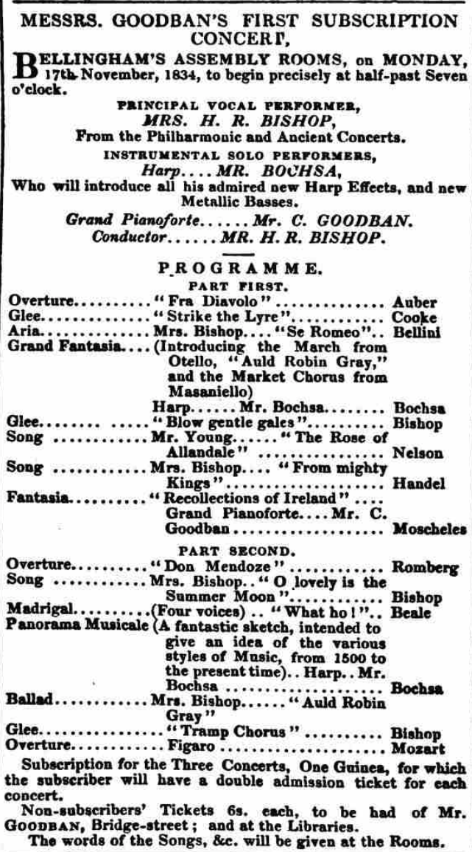

[27]

Figure 7: Newspaper advertisement for Goodban’s Subscription Concert, 17 November 1834

The programme looks very much like a Catch Club evening, each half starting with an overture with another as the finale and including songs and arias from the distinguished soloist (Mrs Bishop) and glees. Robert Nicolas-Charles Bochsa’s appearance as soloist, performing his own *Grand Fantasia* and *Panorama Musicale* should not be ignored; he would have been a big draw. It is a remarkable musical offering, and attracted ‘nearly 350 of the neighbouring and resident gentry,’ according to the local paper.[28] These concerts ran as a small series each year, apparently quite successfully, until 1838, after which Charles Goodban (Thomas’ son) is credited with their organisation for a few years more. It has to be said, though, that this was a cracking start to the project.

The second witness to the musical traffic between London and Canterbury is another source important to musicologists: printed publications, and the subscription lists therein.

Publications, and subscription lists

Composers and teachers were as keen then as they are now to broadcast their productions in the most efficient manner possible.

The most striking of Thomas Goodban’s published output dates from 1818: *Goodban’s Game of Musical Characters* is a musical game, played with a teetotum—a dice on a spindle—and counters on a most elaborate board measuring 531mm x 399mm. It is reproduced as Figure 8. To modern eyes, it’s a daunting conflation of Snakes and Ladders™ and the Associated Board Theory exams, with a system of randomly awarded fines and rewards to tempt—or goad—the young musician on. Goodban’s Preface shows an awareness of musical pedagogy which arguably puts him some way ahead of his time: without compromising on the need to understand the semiotics of musical notation, he is responding to a keenly observed appreciation of its challenges:

As the difficulties of adapting a species of entertainment for such a purpose, suited to the capacities and dispositions of all classes, have been anticipated, no pains or exertions have consequently been spared in the arrangement and formation of the game, to combine an amusement with instruction, in the use and application of it; and by the assistance which it is intended to enable learners, imperceptibly, as it were, to afford to each other—to create a spirit of emulation amongst them, without injuring their morals.[29]

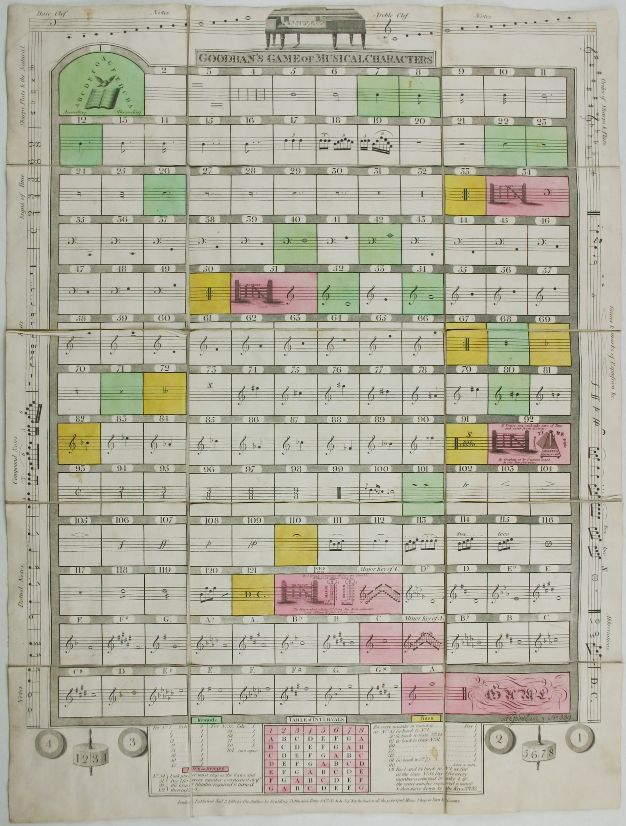

Figure 8: **Goodban’s *Game of Musical Characters* CCA-U85/38/13; reproduced courtesy of the Chapter of Canterbury**

It is an attractive product: musical signs and symbols adorn the border, and a couple of merry little rhymes brighten the players’ progress down the board, such as:

If Praise you seek, take care of Time

And never from it stray;

By crotchets or by quavers count

In ev’ry Bar you play.

Some 230 subscribers are listed at the front of the booklet. Most are local, but the list includes music and booksellers as far afield as Marlborough, Stockport, Norwich, Newport, and Hull. Beyond this, it is difficult to tell how much success the venture brought him, though one contemporary periodical recommended it: the *Quarterly _Musical Magazine and Review_* devoted over four pages to a – largely complimentary – article about it.

The Game had a successor. Much later, in 1845, Goodban produced another game-based method of music instruction: a set of Music Cards. He admits in the Preface that he had made an attempt at this twenty years previously, ‘but becoming perplexed in the formation of the cards so as to make them sufficiently simple for general application, it was then abandoned and the manuscript laid by. A recent discovery of this manuscript has, however, induced [me] to make a fresh attempt.’ The package comprises 4 diagrams, and 48 cards (four sets of twelve) showing notes, rests, and rhythm values, which can be used in various ways in any of the seven games he’s devised. The game was advertised in the local press:

NOVELTY IN MUSIC

Just Published a PACK of FIFTY-TWO MUSIC CARDS and BOOK containing a concise explanation of the rudiments and fundamental principles of the Science of Music, with Rules and Directions for Playing, from characters only, the following instructive and entertaining Games, viz.: …

Written, invented and designed for the purpose of combining instruction with amusement by

THOMAS GOODBAN

Author of a complete Guide to playing the Violin, Instructions for the Pianoforte, the Rudiments of Music, with progressive Exercises to be written upon Slates, &c.[30]

The advertisement goes on to explain that the pack, in its box, costs 5s. and is available from various booksellers. Similar adverts are to be found in the *Spectator* and the *Athenaeum*. The only actual review found to date is a few approving words from the *__Kentish Gazette__* appearing alongside the advert: ‘exceedingly clever and altogether original […] we recommend the ‘music cards’ to every family,’[31] say the editors, after which nothing more comes to light until the _*Musical Times*_ mentioned the game in its obituary in 1863, along with fulsome praise for Goodban’s work in musical education:

As an author Mr. Goodban was formerly well known to the musical world by his instruction books for the violin and pianoforte, and his ‘Rudiments of Music,’ than which no other works of the kind have ever been more extensively used, for at the time they were published (some forty years since) there were none to equal them in attractiveness, clearness of explanation, and adaptability to the powers of the young. [...] We may also add that for integrity, uprightness of character, and kindliness of disposition, no man was ever held in higher estimation by his fellow citizens and all who knew him than Mr Goodban.[32]

There are other nineteenth-century examples of creative attempts at music education in the British Library, but Goodban’s may lay claim to be amongst the most attractive and rigorous examples of such work.

In between the Game and the Cards, as the *Musical Times* records, Goodban had been most industrious. The title page of the Music Cards booklet claims him to be the ‘Author of a complete guide to playing the violin; instructions for the pianoforte; the rudiments of music, with progressive exercises to be written upon slates; etc.’ This is true; copies are in the British Library. In 1840, a second edition of the Piano tutor, with an additional ‘variety of exercises for forming the hands, acquiring independence and facility of action, and contracting and changing them, &c., &c.’, met with an enthusiastic reception from the home crowd: the *__Kentish Gazette__* recommended it as tending ‘more than any perceptive book we have ever seen, to perfect the student in the rudiments of the science.’[33]

All these creations were published in London: the Game by Goulding, D’Almaine, Potter, & Co. of 20, Soho Square; the Cards by Simpkin, Marshall and Co., Stationers Court and J. A. Novello, Dean Street, Soho and 24, Poultry; the Violin Tutor by Preston ‘at his Wholesale Warehouses, 97, Strand’; and the Piano Tutor by Coventry and Hollier, 71, Dean Street, Soho. Such an imprimatur would have ensured a distribution well beyond the city of Canterbury.

Thomas Goodban was not the only important character in Canterbury’s musical history. Another was William Henry Longhurst (1819–1904).

**William Henry Longhurst**

Longhurst’s output is no less impressive: an appreciable number of vocal compositions, both sacred and secular, along with a book of ‘Slate Exercises [...] A collection of exercises on the value of notes, rests, etc. [...] Dedicated to all professors of music for the instruction of their pupils in time’. This is his only foray into music education. The music was published by various London-based houses, amongst whom the most notable names are Novello and Curwen, but the more important point is that several of the pieces were considered worthy of inclusion in collections by both publishers. None of the pieces would prompt a re-appraisal of Longhurst’s modest place in the ranks of English composers, but they are pleasant enough, and would serve their purposes well: an addition to the repertoire of canticles and anthems for a provincial cathedral, or teaching pieces for singing pupils such as ‘The Misses Backhouse’ to whom his *Mermaid’s Song* was dedicated. And for the sake of completeness, it should be noted that the Catch Club was treated to at least one composition which did not make it into print, probably because few would be able to play the piano accompaniment: *The Fairies: In the Stilly Night* was a ‘Cheerful Glee’ for 4 voices which begins innocuously enough but launches into a virtuosic passage for the accompanist whilst the voices trip around singing ‘We step so lightly, gay and sprightly, from eve till the break of day’. Here is an extract; you don’t need to be any sort of musician to appreciate how busy the pianist is – and, by extension, how accomplished Longhurst was:

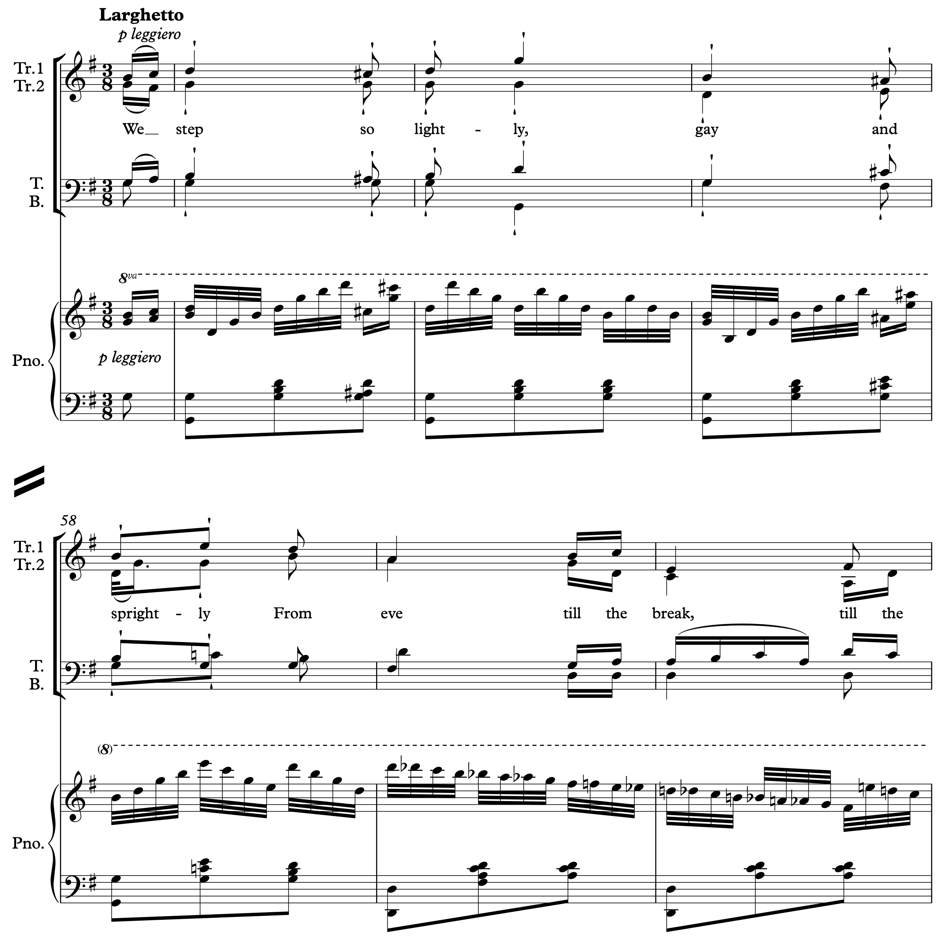

Figure 9: Longhurst: *The Fairies*; bars 54-60

Other publications in the Canterbury collection testify to the journeys music could make across the nation in the eighteenth and nineteenth centuries. Subscription lists are often simply a list of names, but will, not infrequently, give a location. The geographical reach is remarkable. A two-volume set of music by the much-loved John Wall Callcott, edited by his son-in-law, the composer William Horsley, and published in London by Birchall, Lonsdale, and Mills in 1824, is probably the jewel in the Canterbury Collection; the map below (Figure 10) shows in graphic form how far afield Callcott’s music travelled.

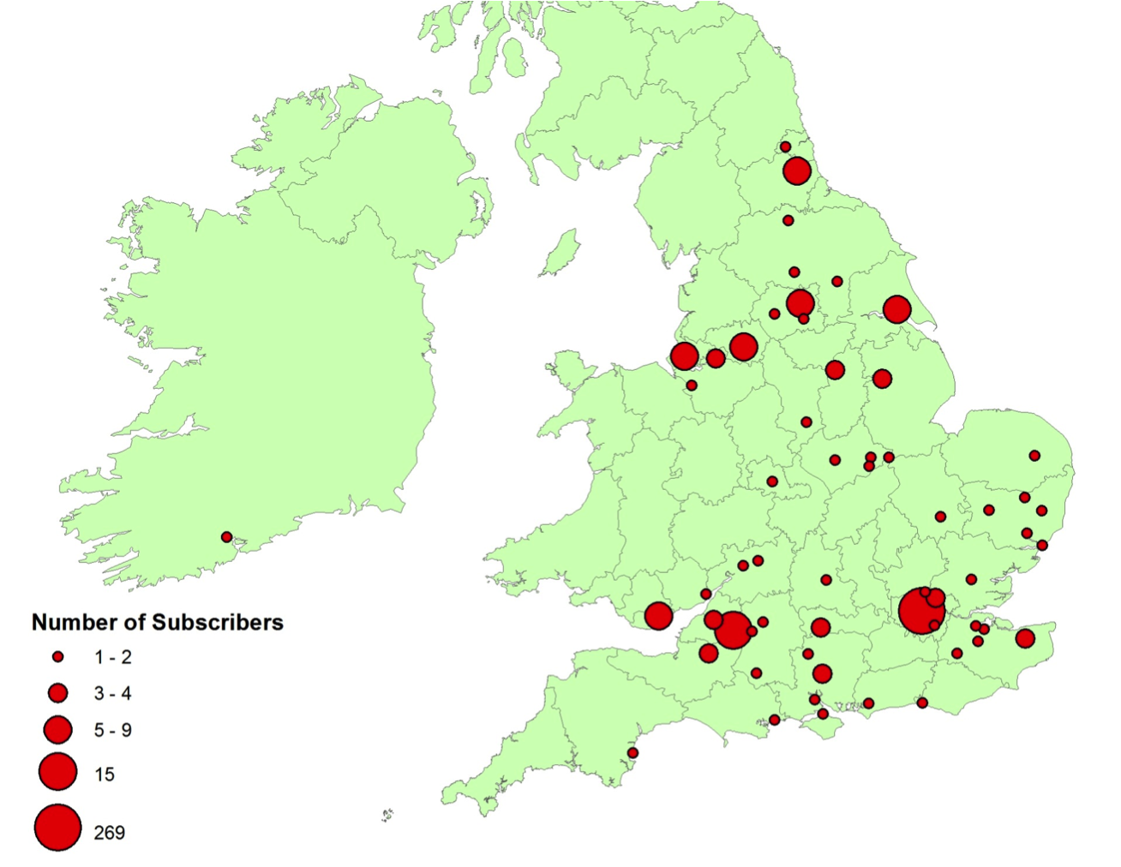

Figure 10: Map showing the locations of subscribers to the 2-volume edition of works by John Wall Callcott

Conclusion

This was an age in which the making of entertainment and its consumption were more closely intertwined than is the case in our own time, when we are almost always the paying customers, distanced from the purveyors of culture, who work away before our dispassionate gaze, whether on stage or screen. An evening at the theatre or the catch club could be a lively affair: notwithstanding the studied relaxation of the men in the lithograph in Figure 3, who seem to be ignoring the orchestra working away in the background as they lounge, chat, sup, and smoke, the tremendous activity recorded in the local papers seems to suggest more commitment than that casual demeanour might betoken. And when the testimony of the contemporary writers is considered, that languid pose seems disingenuous, to put it mildly: it must have been high-octane, visceral fun, bellowing those catches across a crowded room in the early hours of the morning, not least because it gave permission for the abandonment of any facade of respectability – or concern for socio-economic status – for a few precious hours. And for the musicians themselves, scratching part of a living from their art alongside the diurnal round of commerce or business, the club evenings represented a steady source of income (most of the singers at a Catch Club evening in 1855 were paid five shillings – about £24 in today’s money – which may not sound much. But multiply that by even 10 evenings a season, let alone all 30, and it’s not difficult to see why the wrangling over wages became so intense every year).

So a Catch Club evening was probably worth an hour or so in a bumpy coach, with a night on a straw mattress at a local inn before the morning ride home, whether you were a professional or amateur participant. The roads of Kent, it would seem, carried not only commerce, but culture; nourishing recreation as well as relationships, that spidery network on the map is much, much more than an inky archive: the heart and soul of the county’s communities pulse along those pathways, to the accompaniment of the most cheerful, inclusive, good-humoured music-making our land has ever known.

**\*\*Article written by:\*\*** Chris Price

**Bibliography**

Goodban, T. (1818). *Goodban’s Game of Musical Characters.* GB-Lbl; 1042.e.25.

Jackson, W. (1795). On Catches. In *Letters on Various Subjects* (3 ed., pp. 61-71). London: T. Cadell, Jun., and W. Davies.

(1863). Obituary, Thomas Goodban. *The Musical Times and Singing Class Circular*, *11*(244), 70-71. Retrieved from http://www.jstor.org/stable/3352133

Scholes, P. (1920). The[Canterbury Catch Club](https://www.youtube.com/watch?reload=9&v=dbKAb18w72c&t=11s). *The Music Student*, *XII*(8), 468-469.

1. . {Baring-Gould, 1890, #42977@210}
2. . Baring-Gould, 1890, 202–212
3. . Baring-Gould, 1890, 217–8
4. . Baring-Gould, 1890, 212
5. . *__Kentish Gazette__*, 6 May 1834, p. 3
6. . *Kentish Chronicle*, 17 November 1826, p. 4
7. . *Percy Scholes: The[Canterbury Catch Club](https://www.youtube.com/watch?reload=9&v=dbKAb18w72c&t=11s). The Music Student (May 1920), XII (8).*
8. . William Jackson: On Catches. In: *Letters on Various Subjects.* Ed. by London: 1795, p. 64
9. . Dean’s Book. GB-CA; CCA-DCc-DB/8, p. 37
10. . *__Kentish Gazette__, pp. 15 March 1833, 3*
11. . *Ibid., pp. 18 February 1834, 3*
12. . *Ibid., pp. 1 April 1834, 3*
13. . *Ibid., pp. 15 April 1834, 2*
14. . *Ibid., pp. 6 May 1834, 3*
15. . *Ibid., pp. 30 September 1834, 2*
16. . *Ibid., pp. 28 October 1834, 3*
17. . *Ibid., pp. 11 November 1834, 3*
18. . *Ibid., pp. 20 May 1834, 3*
19. . *Ibid., pp. 18 December 1838, 3*
20. . *Ibid., pp. 25 December 1838, 3*
21. . Dean’s Book. GB-CA; CCA-DCc-DB/8, p. 111
22. . *Ibid., p. 238*
23. . Precentor’s Book. GB-CA; CCA-DCc-PB/7, p. inside front cover
24. . *KG; ‘__Kentish Gazette__ template’ __Kentish Gazette__, pp. 11 March 1834, 3*
25. . *Ibid., pp. 3 March 1857, 4*
26. . Precentor’s Book. GB-CA; CCA-DCc-PB/7, p. inside front cover
27. . *KG; ‘__Kentish Gazette__ template’ __Kentish Gazette__, pp. 11 November 1834, 3*
28. . *Ibid., pp. 25 November 1834, 3*
29. . Goodban, 1818, pp. Preface, ii–iii
30. . *KG; ‘__Kentish Gazette__ template’ __Kentish Gazette__, pp. 9 December 1845, 2*
31. . *Ibid.*
32. . Obituary, Thomas Goodban. *The Musical Times and Singing Class Circular* (1 June 1863), 11 (244).
33. . *KG; ‘__Kentish Gazette__ template’ __Kentish Gazette__, pp. 6 October 1840, 3*